**EXPERIMENT 3 : Class Diagram**

**Name: Adwait Purao – 2021300101**

**Viraj Bhalerao – 2022301002**

**Batch: B2/ B**

**Aim:** Class Diagram for Ferry Ticketing System

**Problem Statement:** A ferry company wants to implement a ticketing system for their ferry services. The system should handle ticket booking, payment processing, and passenger management. There are two main user roles: Passengers and Administrators. Passengers can search for ferries, book tickets, cancel tickets, and make payments. Administrators can generate reports, schedule ferries, manage users, and update ferry details.

**Noun/Noun Phrases:**

* User
* Passenger
* Administrator
* Ticket
* Payment
* Ferry
* Booking
* Ferry Service
* Report

**Classes:**

* User (Generalized class for Passenger and Administrator)
* Passenger
* Administrator
* Ticket
* Payment
* Ferry
* Booking
* Ferry Service
* Report

**Verb Phrases:**

1. Passenger searches for available ferries.
2. Passenger books a ticket.
3. Passenger cancels a ticket.
4. Passenger makes a payment.
5. Administrator generates reports on ferry operations.
6. Administrator schedules ferries.
7. Administrator manages users.
8. Administrator updates ferry details.

**Relations:**

1. Passenger and Administrator are users of the system, hence they can be generalized to a User class.
2. A Passenger can book one or more Tickets.
3. A Ticket is associated with one Passenger.
4. A Ticket is linked to one Ferry for a specific Ferry Service.
5. A Booking contains one or more Tickets.
6. A Booking is associated with one Passenger.
7. Administrators can schedule one or more Ferries.
8. A Ferry Service includes one or more Ferries.
9. Administrators can manage one or more Users (Passengers).
10. Administrators can update details for one or more Ferries.
11. Administrators can generate Reports on Ferry operations.

**Diagrams:**

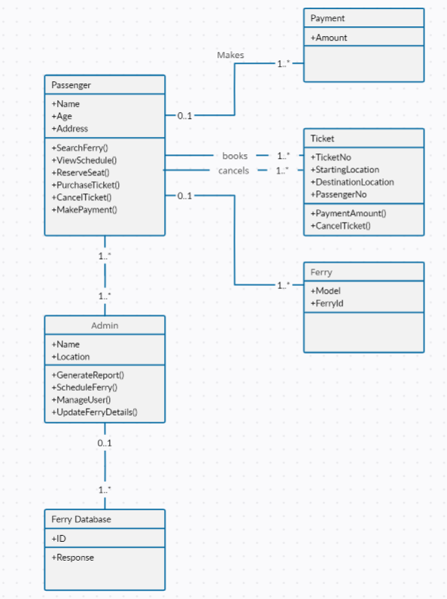

**Conclusion:**

Hence, I created the class diagram for Ferry Ticketing System application and understood relationship between various classes